CREATION OF DATABASE

Create database HOSPITAL;

USE OF DATABASE

use database HOSPITAL;

CREATION OF TABLES

1. Hospital_info

create table Hospital_info (hospital_id int,

name varchar(20),

address varchar(50)

);

select*from Hospital_info details;

1. PATIENT

create table patient( patient_id int,

patient_name varchar(20),

age int,

mobile_no int);

1. DOCTOR

Create table Doctor(doctor_id int,

doctor_name varchar(20),

patient_name varchar(20),

patient_id(int),

patient_age int,

contact_no int);

1. PRESCRIPTION

Create table Prescription(patient_id int,

medication_details varchar(20),

dosage int);

INSERTING THE DATA

1. HOSPITAL
2. PATIENT

insert into patient values (1,'Ankur Singh',28,1234567890);

insert into patient values (2,'Aman soni',30,1234567891);

insert into patient values (3,'Palak Garg',26,1234567892);

insert into patient values (4,'Kirti Vijay',28,1234567893);

insert into patient values (5,'Anjali Sharma',32,1234567894);

insert into patient values (6,'Sakshi Agrawal',20,1234567895);

select* from patient;

1. DOCTOR

insert into DOCTOR values(101,'ASHISH JAIN','Palak Garg',3,26,1234567892);

insert into DOCTOR values(102,'JATIN SHARMA','Aman soni',2,30,1234567891);

insert into DOCTOR values(103,'ASHISH KUMAR','Sakshi Agrawal',6,20,1234567895);

insert into DOCTOR values(104,'SANDEEP JAIN','Kirti Vijay',4,28,1234567893);

insert into DOCTOR values(105,'RAEES KHAN','Ankur Singh',1,28,1234567890);

insert into DOCTOR values(106,'ALOK SHARMA ','Anjali Sharma',5,32,1234567894);

insert into DOCTOR values(107,'MANISH SHARMA ','Aman soni',2,30,1234567891);

insert into DOCTOR values(108,'SUDHANSHU AGRAWAL','Palak Garg',3,26,1234567892);

select * from DOCTOR;

1. PRESCRIPTION

insert into Prescription values (4,'fever and cold',2);

insert into Prescription values (3,'appendix',4);

insert into Prescription values (2,'asthma',1);

insert into Prescription values (1,'fever and cold',2);

insert into Prescription values (6,'stomach infection',2);

insert into Prescription values (5,'liver infection',2);

select * from Prescription

RETRIEVAL OF DATA

* HOSPITAL

Select *from hospital

* PATIENT

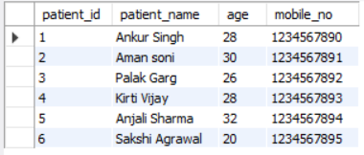

* DOCTOR

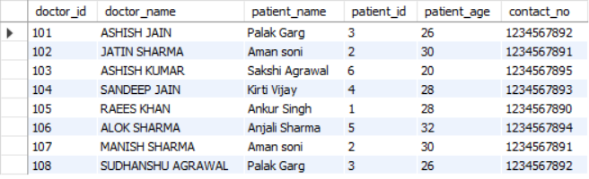

* PRESCRIPTION

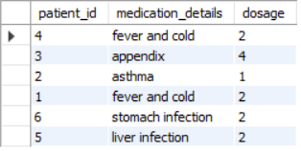

OPERATORS

**AND**

SELECT * FROM DOCTOR WHERE PATIENT_AGE BETWEEN 20.0 AND 30.0;

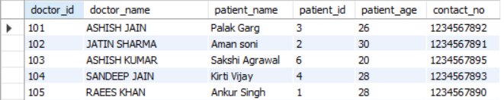

OR

SELECT * FROM doctor WHERE patient_id = 1 OR patient_id = 2;

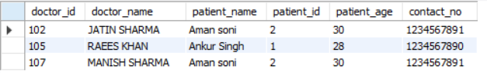

IN

SELECT * FROM patient WHERE patient_id IN (1, 3, 5);

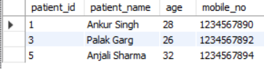

● BETWEEN

SELECT * FROM DOCTOR WHERE PATIENT_AGE BETWEEN 20.0 AND 30.0;

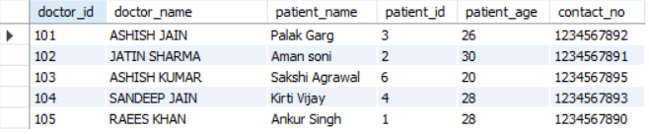

● ORDER BY

SELECT * FROM Prescription ORDER BY dosage ASC;

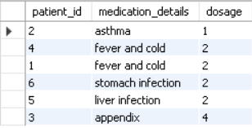

● LIKE

SELECT * FROM customer WHERE name LIKE 'A%';

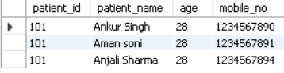

● LIMIT

SELECT * FROM Prescription LIMIT 5;

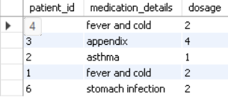

● OFFSET

SELECT * FROM product LIMIT 5 OFFSET 5;

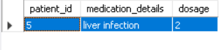

* AGGREGATE FUNCTIONS

There are following aggregate functions: sum, min, max, count and avg.

1. SUM

SELECT SUM(dosage) FROM Prescription;



1. AVG

SELECT AVG(total_amount) AS average_sales_amount FROM sale;

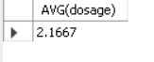

1. MAX

SELECT MAX(total_amount) AS max_sale_amount FROM sale;



4.MIN

SELECT MIN(dosage) FROM Prescription;

